Reflections on Race, Identity & the Art of Kara Walker
Figure Study Paper Cutouts
Art 3 – 5

Homework (this research will help you tremendously in creating your project, be THOROUGH) 100 points/daily grade/due tomorrow:

Research your family’s background. Where did your family come from and how did they get here? Go back as far as you can in your family history.

Describe interesting historical narratives in your familial background.

What are some challenges the people of your culture have had to overcome?

Look this up! What types of artwork have your cultural relatives created?

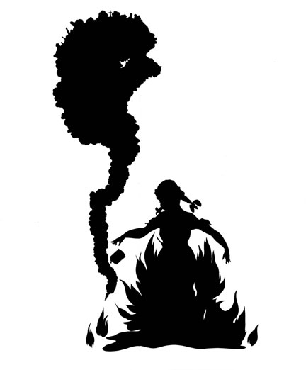
Kara Walker
¨The Burn”
What is happening in this image?
What is the message the artist is attempting to convey?
Why is it compositionally strong?

The Project:
Objective: After viewing the PowerPoint about Kara Walker and her art, you will create a paper cutout image exploiting the use of the figure to convey a message relating to your personal identity and narrative. DUE DATE: _____________________________

Criteria:
- Utilize Kara Walker’s method of creating a paper cutout.
- Show excellent skill and craftsmanship.
- Clearly convey a message about your personal or cultural narrative.
- Utilize at least one figure, making sure proportion is accurate and the potential of the human form is fully utilized. Think about movement and pose. Figure MUST be you &/or family members.
- Show strong composition and justify your compositional layout.

Self Evaluation Questions:

- Did you utilize Kara Walker’s method of creating a paper cutout?

- How well did you show excellent skill and craftsmanship with the medium?

- Describe your message and how your work clearly conveys this message about your personal or cultural narrative.

- Who did you utilize as your model(s) for this image? Why? Is your proportion accurate and is the potential of the human form fully utilized?

- In ONE COMPLETE sentence, explain why your composition is interesting.

- Give yourself a grade out of 100 points and explain why you deserve this grade.

